Alert Watch and Response Engine (AWARE)

User Interface Document



May 2014

Prepared by Harris Corporation

CLIN 0002AB

Revision History

| Creation Date | Version No. | Description/Comments | Author(s) | Reviewer(s) | Review Type | Issue Date |
| --- | --- | --- | --- | --- | --- | --- |
| 10/16/2013 | 0.01 | Initial | I. Valdes |  |  | 11/14/2013 |
| 04/23/2014 | 0.02 | Added Sections 4.2.1 and 4.2.2; Updated Table 1; Added Figures 20 through 51.  Changed Verbiage in section 1.2, 2.1, 2.2, 2.5, 3, 3.1, 3.2, 4.2, 4.2.1, 4.2.2 | B. Tjahjo | S. Greenacre S. Wang M. Becker G. Welch | Peer | 05/29/2014 |
|  |  |  |  |  |  |  |
|  |  |  |  |  |  |  |
|  |  |  |  |  |  |  |
|  |  |  |  |  |  |  |
|  |  |  |  |  |  |  |
|  |  |  |  |  |  |  |
|  |  |  |  |  |  |  |
|  |  |  |  |  |  |  |
|  |  |  |  |  |  |  |
|  |  |  |  |  |  |  |
|  |  |  |  |  |  |  |

Table of Contents

1 Introduction 1

1.1 Purpose 1

1.2 Overview 1

1.3 Related Documentation 2

1.4 Acronyms and Abbreviations 2

2 User Interface Summary 2

2.1 System Configuration 2

2.2 AWARE Data Flows 4

2.3 User Access Levels 5

2.4 Contingencies and Alternate Modes of Operation 5

2.5 Logging On 5

3 User Navigation 5

3.1 Workflow for Requested Follow-Up Action 6

3.2 Alert Acknowledge/Deletion with an Auto-Renewal 15

3.3 Exiting the System 17

4 Rules Engine, QI Tool, Reporting 17

4.1 Knowledge-Base Rules Engine (KB Editor) 17

4.2 QI Tool 23

4.2.1 Alert Cache Viewer 23

4.2.2 QI Reporting Tool 27

5 Attachment A - Approval Signatures 42

List of Tables

Table 1 – Acronyms and Abbreviations 2

List of Figures

Figure 1 - Conceptual Flow Diagram 3

Figure 2- AWARE Data Flows 4

Figure 3 - Select New Patient 6

Figure 4 - Normal CPRS Patient Selection Screen 7

Figure 5 - Prompt Screen 8

Figure 6 - TIU Template/Reminder Dialog 8

Figure 7- Location for Current Activities 9

Figure 8 - Select Progress Note Title 9

Figure 9- Reminder Dialog 10

Figure 10 - Order Example 11

Figure 11- Completing Orders and other Follow-Up Actions 12

Figure 12 - Signing the Order(s) 13

Figure 13 - Review/Sign Changes 13

Figure 14 - Patient Chart Closeout 14

Figure 15 - Prompt for Follow-Up Actions Not Completed 15

Figure 16 - Acknowledge Abnormal Mammogram Alert 16

Figure 17- Acknowledged/Deleted Alert Was Automatically “Renewed” 16

Figure 18 - Notification Window with Alert List 17

Figure 19 - List of Alert Categories 18

Figure 20 - Alert Category Form 18

Figure 21- List of Alert Types 19

Figure 22 - Alert Type Form 19

Figure 23 - List of Follow-up actions in Order Dialog Group 20

Figure 24 - Follow-up action Form of Order Dialog Group 21

Figure 25 - List of Follow-up actions in Follow-up Dialog Group 21

Figure 26 - Follow-up action Form of Follow-up Dialog Group 22

Figure 27- List of Follow-up actions in Comment Dialog Group 22

Figure 28 - Follow-up action Form of Comments Dialog Group 23

Figure 29 - List of Cached Critical Alerts 24

Figure 30 - Detail: Cached Critical Alert Information (GENERAL) 25

Figure 31 - Detail: Cached Critical Alert (FAT/STATUS) 26

Figure 32 - Detail: Cached Critical Alert (RESULT) 26

Figure 33 - Detail: Cached Critical Alert (FOLLOW-UP ACTIONS) 27

Figure 34 - QI Report Manager Logon screen 1 28

Figure 35 - QI Report Manager Logon screen 2 29

Figure 36 - Validated as Super User 30

Figure 37 - Validated as Local Application User 31

Figure 38 - Validated as VistA User 31

Figure 39 - Dynamic Reports Parameter panel 32

Figure 40 - Selected Reports Generated. 33

Figure 41- QI Tool Administration Tools 34

Figure 42 - QI Group Panel – Add Mode 34

Figure 43 - Available Reports Drop-Down List 35

Figure 44 - Group Members Drop-Down List 35

Figure 45 - Delete QI Group Warning 36

Figure 46 - VistA Groups Panel – Add Mode 37

Figure 47 - VistA Groups – Aware Group Drop Down List 38

Figure 48 - VistA Group Deletion warning 39

Figure 49 - Users Panel – Add Mode 39

Figure 50 - Delete User Warning Prompt 40

Figure 51 - Reports Panel 41

# Introduction

The Computerized Patient Record System (CPRS) View Alerts package delivers notification of non-life threatening critical test results; however, it does not track whether providers take appropriate follow-up actions in response to the alerts. Currently, the only way to track follow-up actions on critical alerts is through a manual review of individual patient records. The innovation Alerts, Watch and Response Engine (AWARE) will track and monitor follow-up actions and will identify certain critical lab and imaging test result alerts that lack timely follow-up.

## Purpose

The purpose of this document is to describe the user interaction with the AWARE application, and the AWARE interface to CPRS. It will familiarize users with the important features and navigational elements of the AWARE product.

## Overview

CPRS integration for AWARE functions is the core part of the AWARE system for specific tracked patient test result alerts. It is the basis for interjecting a prompting to a patient’s provider with an opportunity for CPRS re-direction for doing timely follow-up actions on these alerts. When these follow-up actions are completed, they can help serve VA-desired goals of providing more timely and proper patient care with patient safety considerations in mind.

At present, there is little to no special notification of normal, abnormal, and incomplete test results, such as those indicative of a cancer. Critical alerts occur in the system, but very little tracking, follow-up information, special notification or decision support occurs, other than what is present in the base system.

From a user’s perspective with CPRS, the AWARE system:

* Provides an AWARE prompt to notify the user that an unacknowledged, abnormal result alert type exists for a patient that has not had follow-up.
* Allows for a decision-support workflow that guides the user towards appropriate follow-up actions desired for that alert before an acknowledgement/deletion is allowed.

AWARE, with its reminder-based services indicating the need for follow-up actions to patients, who could be forgotten, can be of major assistance to CPRS clinicians in delivering a high level of care. CPRS uses client/server architecture, and AWARE’s re-direction of flow is made only to regular CPRS functions. Access to AWARE’s functionality is through two CPRS paths:

* At time of patient closeout, when selecting a new patient from the “File” Menu in CPRS, a prompting screen for flow re-direction is presented for use with the prior patient when AWARE has detected that no follow-up action(s) has been completed for any associated unacknowledged tracked test results alert(s) for that patient.
* At time of an AWARE alert acknowledge/deletion, with a denial of this action with an auto-renewal of that alert when the associated AWARE follow-up action(s) has not been completed.

This system enables those responsible for clinical services to help insure greater patient safety with more optimal care delivery.

VA Reminder Dialogs are the natural tools for providers to enter follow-up actions for unacknowledged alerts under AWARE. These include components such as medication, lab test and text orders, consults, procedures including imaging and also comments/observations that are mapped to equivalent VA FileMan files.

## Related Documentation

* AWARE CPRS Integration Specification

## Acronyms and Abbreviations

Table – Acronyms and Abbreviations

| Acronym/Abbreviation | Definition |
| --- | --- |
| AWARE | Alert Watch and Response Engine |
| CPRS | Computerized Patient Record System |
| FAT | Follow-up Action Tracking |
| TIU | Text Integration Utilities |
| VA | Department of Veterans Affairs |
| VistA | Veterans Health Information Systems and Technology Architecture |

# User Interface Summary

The following sections provide a summary of the AWARE user experience. The AWARE user interface with CPRS is a “prompting” screen with opportunity to invoke a follow-up action(s) on tracked unacknowledged alerts having no prior follow-up(s). This screen provides guidance to the user for these flow redirection steps, as well as an opportunity to perform follow-up actions within subsequent CPRS Reminder Dialog screens.

## System Configuration

CPRS processing on workstations communicate with a VistA server on a network via broker Remote Procedure Calls (RPCs). A conceptual flow diagram of the whole AWARE system is shown in Figure 1 below including a reporting component for quality indicator (QI) purposes.

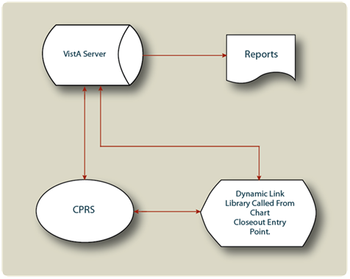

Figure - Conceptual Flow Diagram

## AWARE Data Flows

Figure 2 below illustrates the flow of data through AWARE.

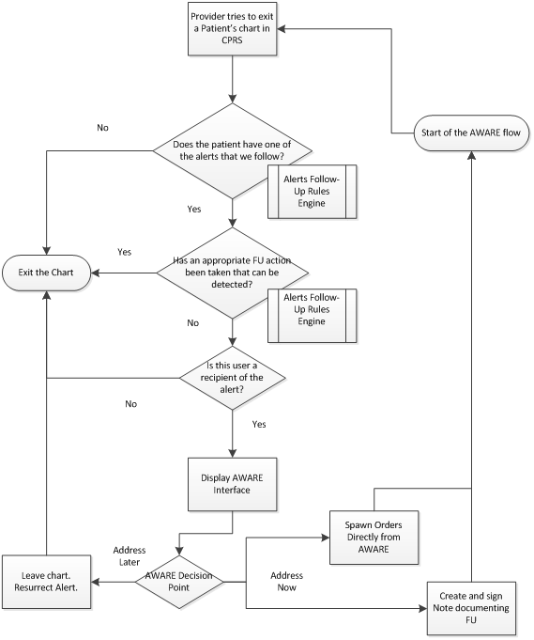

Figure - AWARE Data Flows

## User Access Levels

The user(s) of allowed AWARE processing in CPRS for tracked non followed-up test result alerts under AWARE are clinicians for their own patients as well as other providers on the same CPRS team. Those users can see the same unacknowledged alert in their notification window in the patient selection dialog box in CPRS, with restrictions on who is allowed to make certain follow-up actions, such as orders. These are the user(s) that are allowed to make any required follow-up action(s) associated with this type of unacknowledged alert under AWARE.

## Contingencies and Alternate Modes of Operation

The continuity of operations in the event of an emergency, disaster, or accident is the same as the existing VistA and CPRS systems. AWARE must be used with CPRS. If CPRS is down, AWARE cannot run.

## Logging On

A clinical user’s configuration needs to be setup in CPRS before AWARE access is enabled, and this is accomplished by Clinical Application Coordinators and Operations. User privileges must be set up to use AWARE, and a user’s workstation must have a CPRS com object DLL registered for the use of AWARE. The user privileges can be done for individual user, or by groups of users, such as groups by service, etc. This setup is outside the scope of the user interface explained in this document. This setup and additional, related information can be found in the separate AWARE Installation Guides:

* KIDS and CSP Installation Guide (T4_AWARE_InstallGde_KIDS_CSP)
* Server Installation Guide (T4_AWARE_InstallGde-Server)

After this setup is completed, logging on to CPRS with normal CPRS access is all that is required to be able to start using the AWARE functionality.

# User Navigation

During patient chart closeout event (when user is selecting a new patient), user will be presented with an unacknowledged tracked alert under AWARE. A Clinical Application Coordinator at each VA facility will configure the types of alerts that are tracked at that facility. The delivered tracked alert types for AWARE installation include a critical PSA lab test alert, a critical Fecal Occult Blood alert, an abnormal x-ray alert, and Abnormal Mammogram alert. The ones used at a facility depend on the setup made at that facility. Under AWARE this alert type is tracked for the completion of an associated follow-up action(s) allowed for this type of alert.

A scenario for an AWARE flow-path follows:

An AWARE tracked test result alert occurs for a patient. This unacknowledged alert is watched through the AWARE system. The ordering provider of this alert is reminded of follow-up action needed when in that patient’s chart in CPRS. This is when a “select new patient” is desired (i.e., at time of this prior patient closeout). A response is made to this tracked alert at that time by AWARE system. The depiction of this is presented in section 3.1with the execution of steps for doing a follow-up action in Section 3.1.

As another feature, if acknowledgement of this alert is attempted and AWARE has detected no follow-up action(s) has been made on this alert, and then alert acknowledgement is denied and the alert is automatically renewed. The depiction of this is presented in section 3.2 along with the execution of steps for doing a follow-up action in Section 3.2.

## Workflow for Requested Follow-Up Action

The process starts with a patient closeout by selecting a new patient. See Figure 3 below:

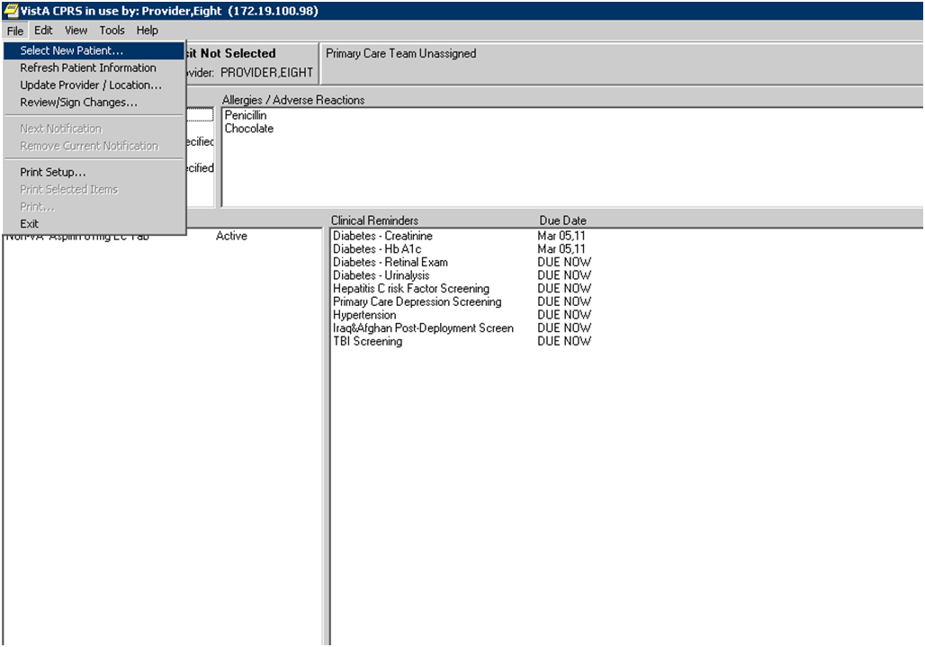

Figure - Select New Patient

The normal CPRS patient selection screen as shown in Figure 4 below will not present directly upon patient closeout if any AWARE tracked test result alert for that provider’s patient has been found on which no follow-up action(s) has been taken.

**NOTE**: A “provider” in this instance refers to the ordering provider for the unacknowledged alert, or can be a surrogate for that provider, or another provider on the same team as the ordering provider. A “user”, in general, could mean this provider or another user who can act on the unacknowledged alert and who has the capability for doing follow-up orders (i.e., a clinician).

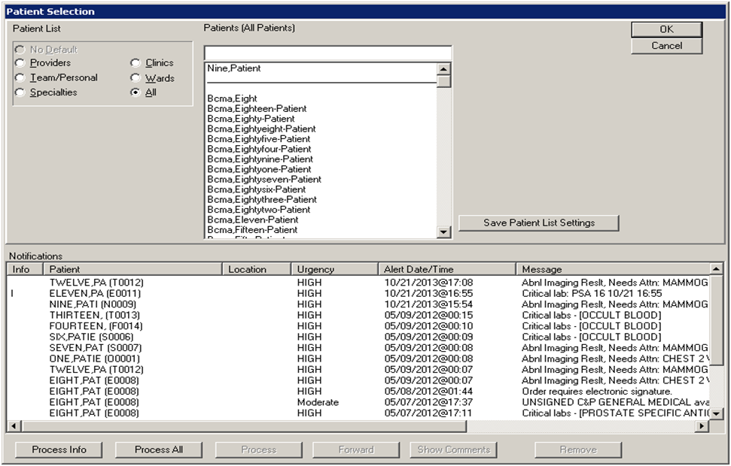

Figure - Normal CPRS Patient Selection Screen

Instead, an AWARE “prompt screen” is presented (see Figure 5 below) to the provider upon patient closeout for an opportunity to perform a CPRS flow redirection that will automatically bring up a Reminder Dialog to do follow-up action(s).

Under this scenario, upon a Patient Chart Closeout when initiating a New Patient selection, a screen similar to that below will appear. This is an AWARE prompt screen, which provides opportunity for CPRS flow re-direction to automatically bring up a Reminder Dialog to satisfy any follow-up action(s) needed.

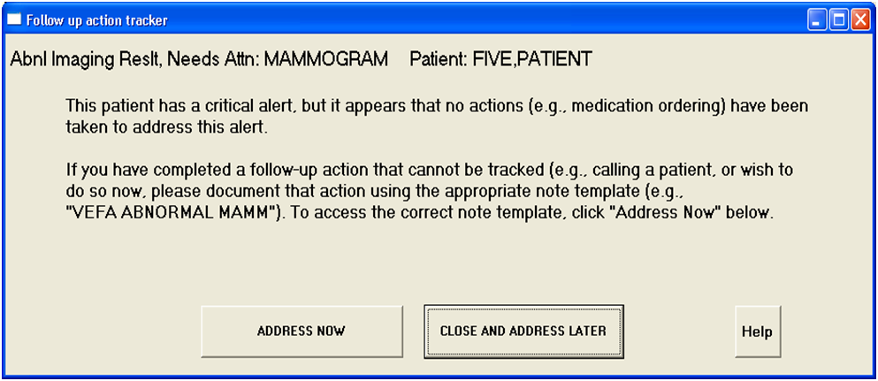

Figure - Prompt Screen

Clicking the “Address Now’ button will automatically bring up the sequence toward an appropriate redirected TIU Template/Reminder Dialog as shown in Figure 6 below. A highlighted Template “VEFA ABNORMAL MAMM” is shown in the Template drawer with a redirection for first specifying a new visit.

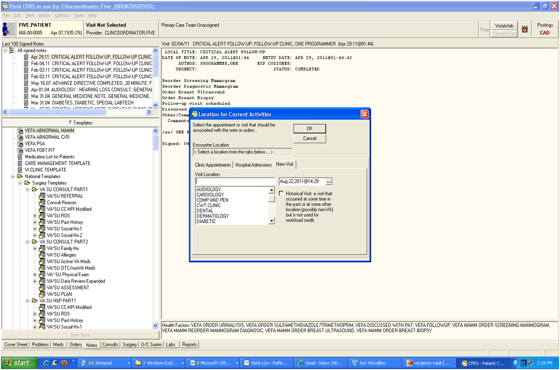

Figure - TIU Template/Reminder Dialog

With a Visit Location prompt for a new visit automatically presented for clinic choice, choose an appropriate clinic. Figure 7 below uses the “Follow-up clinic” as an example provider clinic. This could be any provider’s clinic.

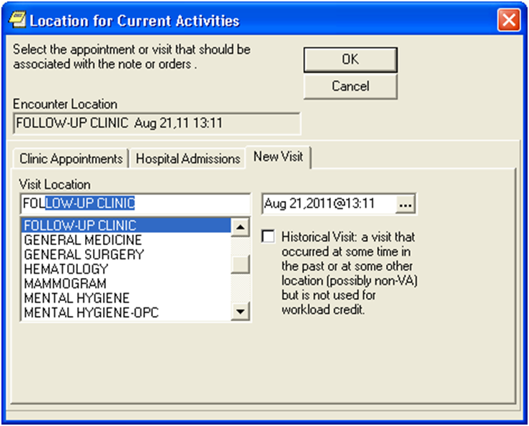

Figure - Location for Current Activities

Next, select the appropriate Progress Note Title as shown in Figure 8 below.

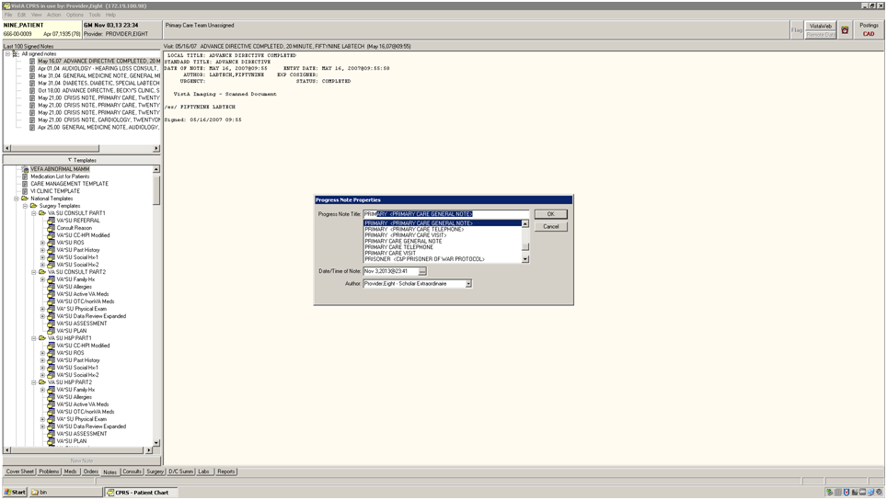

Figure - Select Progress Note Title

A Reminder Dialog should appear next as shown in Figure 9 below.

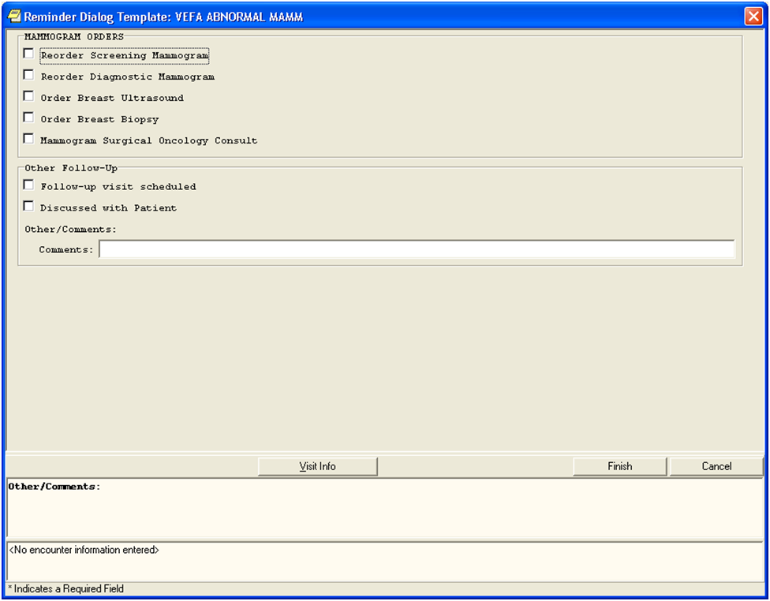

Figure - Reminder Dialog

Make appropriate follow-up action selection(s) as in example above, and the click the “Finish” button to initiate follow-up actions.

If a follow-up action is not made from this screen, a patient closeout will initiate the AWARE prompt screen again. Any follow-up order made must also be signed, otherwise the AWARE prompt will again be presented at patient closeout; the user must click and sign the appropriate order(s) made. Also clicking and accepting of a text follow-up action(s) in the Reminder dialog itself is sufficient to allow the bypass of the prompt screen at patient closeout. See the order and text follow-up example in Figure 10 below.

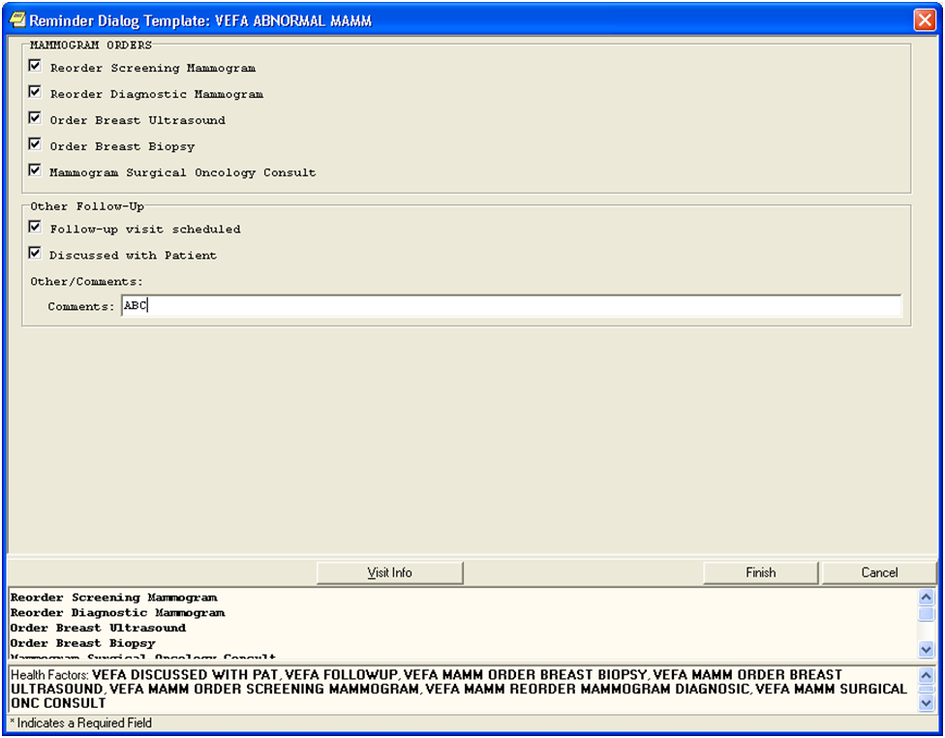

Figure - Order Example

The follow-up actions can be orders and/or non-order follow-up actions. If no order follow-up actions are clicked, but other non-order follow-up actions are clicked, these actions will still allow completing an AWARE workflow on the next Patient Chart Closeout without continued AWARE prompting.

The documentation for completing any orders (medication, lab test, etc), consults, procedures including imaging, etc) and other follow-up actions are also stored in the resulting progress note for a completed Reminder dialog. This is shown in the progress note shown below as an example of a follow-up action taken:

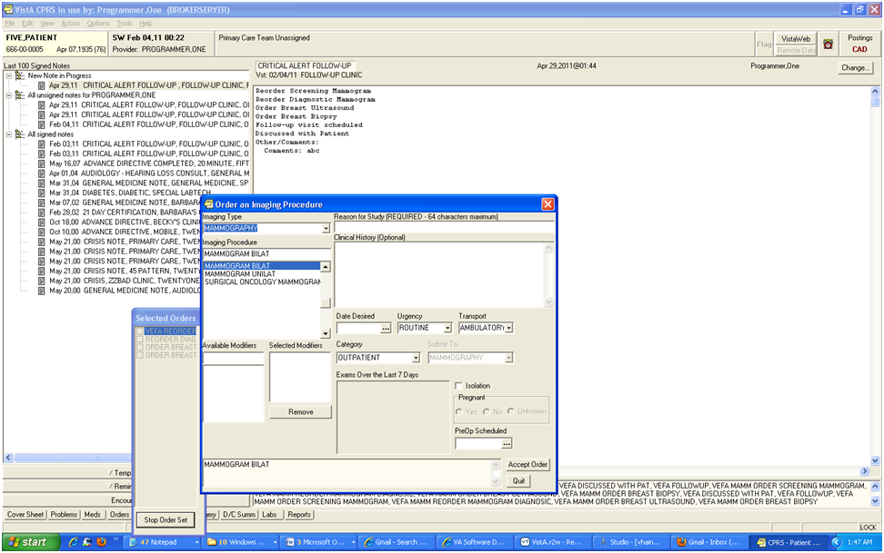

Figure - Completing Orders and other Follow-Up Actions

Next, sign order(s) as required in order to allow the bypass of an AWARE prompt screen on a Patient Chart Closeout. This also allows a subsequent acknowledge/deletion of this alert.

Continue with the signing of the order(s):

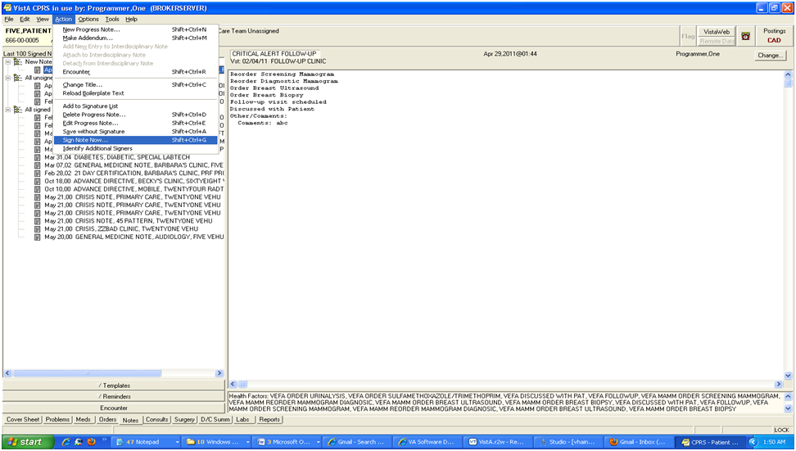

Figure - Signing the Order(s)

Diagnosis and service-connected conditions may be required upon the signing of orders.

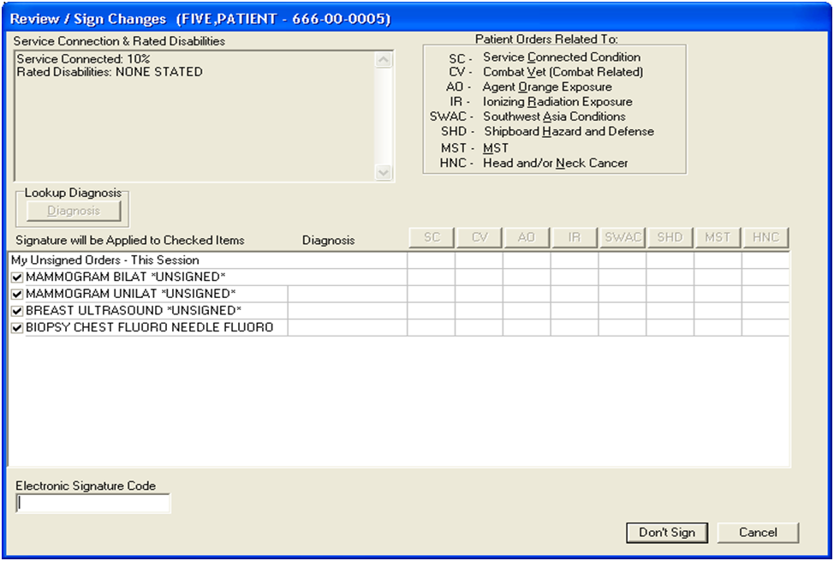

Figure - Review/Sign Changes

Pertinent Orders to satisfy follow-up actions do not have to be made through the “Address Now” button from an AWARE prompt on Patient Chart Closeout. These can be done independently, and when completed will satisfy the follow-up action required.

The below AWARE prompt screen is always for the most recent AWARE type critical alert for a patient needing some sort of follow-up action. As soon as the follow-up action of this most recent alert is completed, any next-most-recent unacknowledged AWARE type alert will allow prompting, provided there is a needed follow-up action on this particular alert. The process is allowed for consideration of any next alert, and so forth.

If unsigned orders still exist, a Patient Chart Closeout is presented with an AWARE prompt as below:



Figure - Patient Chart Closeout

Clicking “Address Now” will automatically go to the “Orders” tab.

## Alert Acknowledge/Deletion with an Auto-Renewal

When follow-up actions have not been completed upon a Patient Chart Closeout, an AWARE prompt appears as in example shown in Figure 15 below:

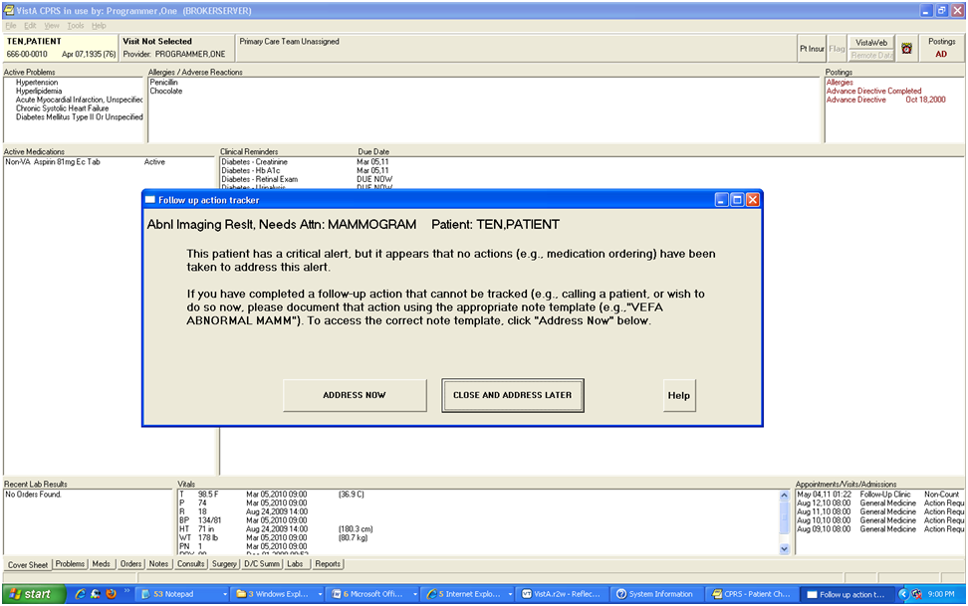

Figure - Prompt for Follow-Up Actions Not Completed

Click the “Close And Address Later” button to address AWARE alerts at a later time. Figure 16 below shows an example of a subsequent attempt to acknowledge an Abnormal Mammogram Alert (on which AWARE has detected no follow-up action(s) has been made.

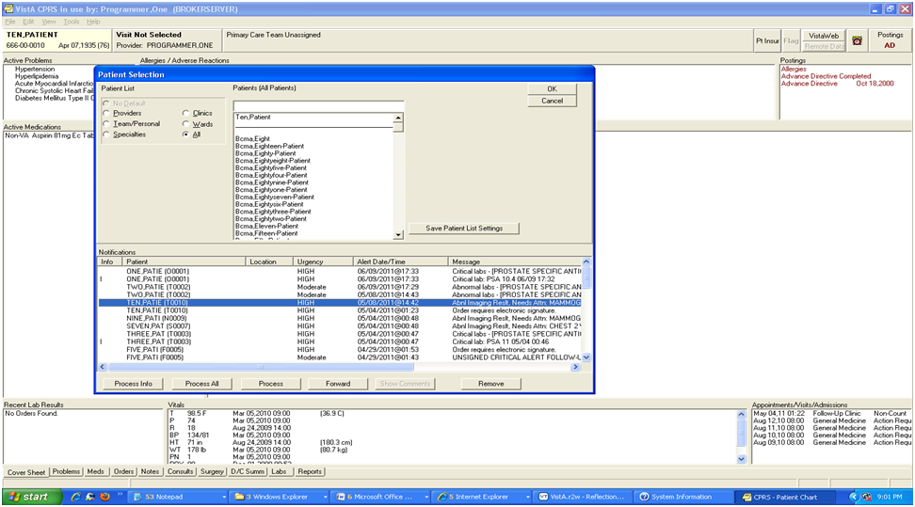

Figure - Acknowledge Abnormal Mammogram Alert

Acknowledging the selected alert in the Notifications Window with the “Process” button will deny a deletion (acknowledgement) of the alert with a renewal of the alert.

Performing another Patient Chart Closeout presents an AWARE prompt screen again as shown in Figure 17 below, signifying the acknowledged/deleted alert was automatically “renewed”.

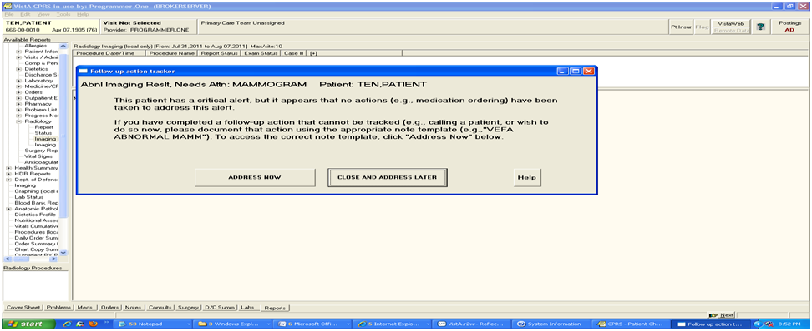

Figure - Acknowledged/Deleted Alert Was Automatically “Renewed”

Click the “Close And Address Later” button to display a notification window with the alert list again as shown in the Figure 18 below.

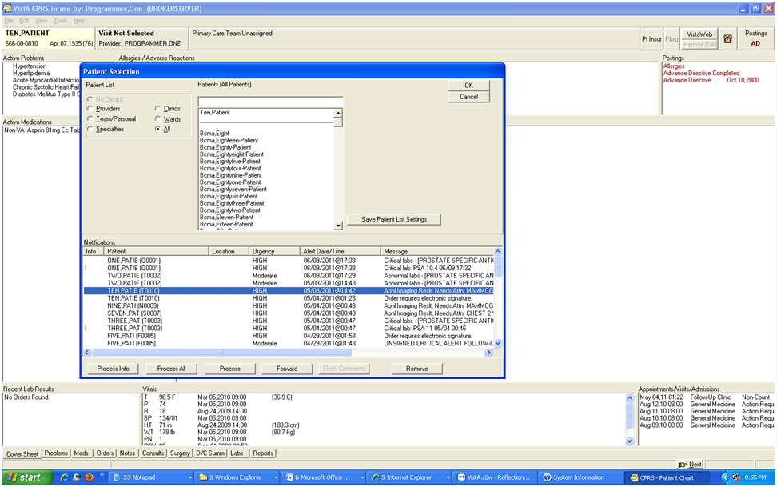

Figure - Notification Window with Alert List

The same Alert is still displayed as a renewed Alert.

## Exiting the System

AWARE is active until the user exits CPRS (a patient closeout without any AWARE prompt).

# Rules Engine, QI Tool, Reporting

Per enhancements requirements, the Rules Engine Editor and QI Tool are designed as web applications. For the Rules Engine editor called the Knowledge Base (KB) Editor, Clinical Application Coordinators (CACs) will be the primary users. For the web based reporting QI tool, the primary users will be provider clinicians, patient safety officers, and other administrative staff. Summaries of these applications are described below.

## Knowledge-Base Rules Engine (KB Editor)

This web editor of knowledge base rules determines which alert categories and alert types to track. The user interface has been developed to do those activities as part of the enhancements requirements. It will reference an associated Reminder Dialog for a recommended re-direction of CPRS flow to do follow-up actions via this Reminder Dialog for unacknowledged AWARE type tracked alerts. The editor will also perform verification of the associated components. This web-based editor will be used by CACs with proper logon and access to configure AWARE for the particular kinds of alerts to track for a particular site. This is in addition to the normal CPRS/VistA reminder dialog building tools used presently. , , , and below show KB Editor Web Interface displaying and editing Alert Categories and Alert Types.

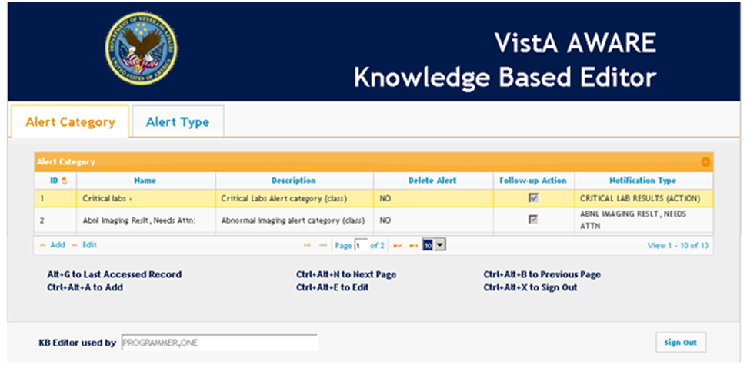

Figure - List of Alert Categories

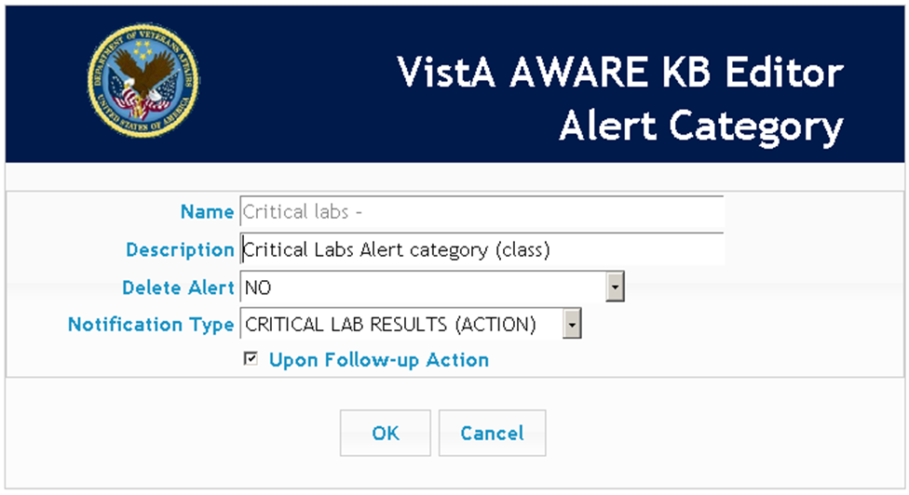

Figure - Alert Category Form

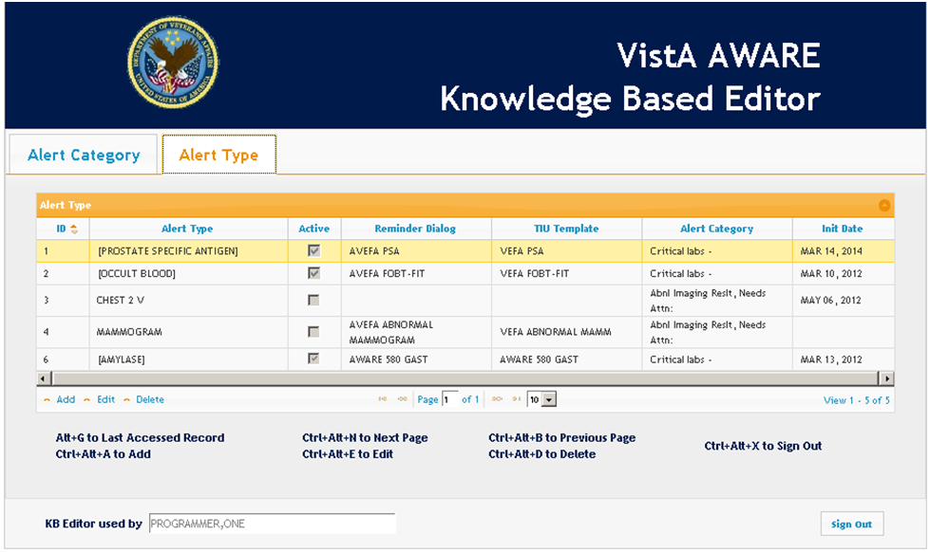

Figure - List of Alert Types

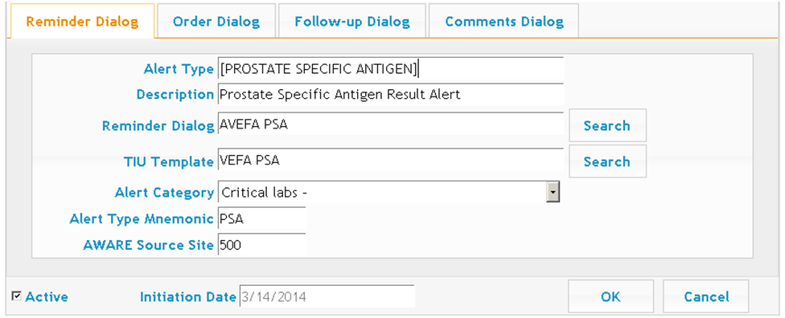

Figure - Alert Type Form

Each Alert Type defines follow-up actions. AWARE provides three follow-up action groups based on their usage or functionality (Order Dialog, Follow-up Dialog, and Comments Dialog). Figure 23 through Figure 28 show the user interfaces for those follow-up action groups.

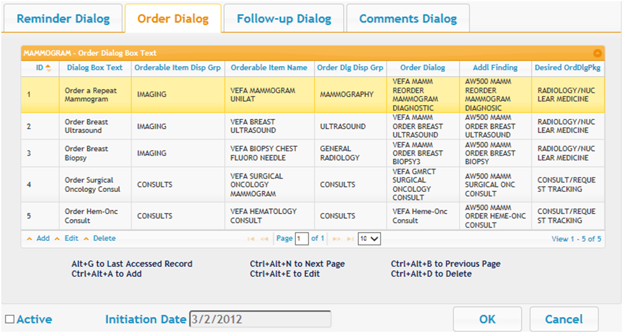

Figure - List of Follow-up actions in Order Dialog Group

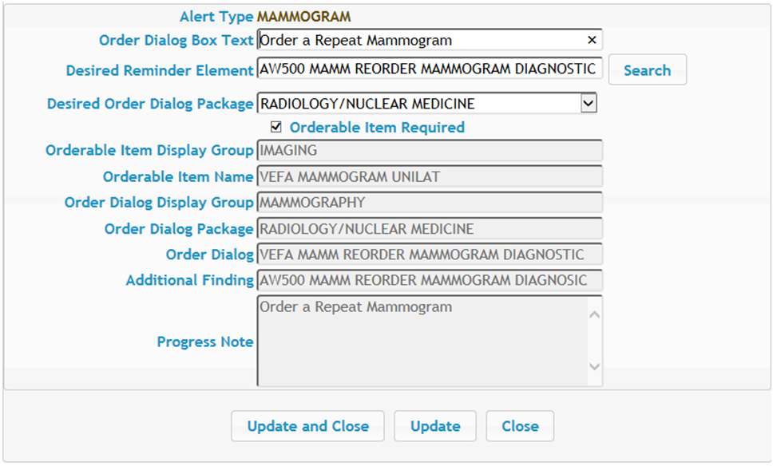

Figure - Follow-up action Form of Order Dialog Group

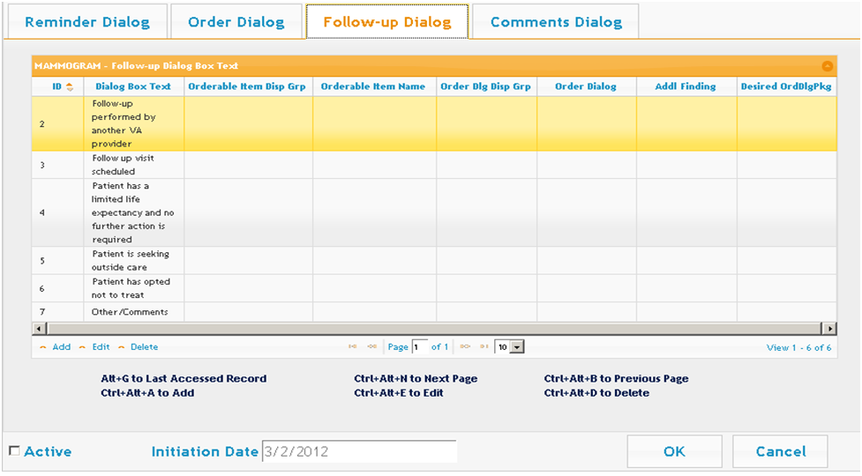

Figure - List of Follow-up actions in Follow-up Dialog Group

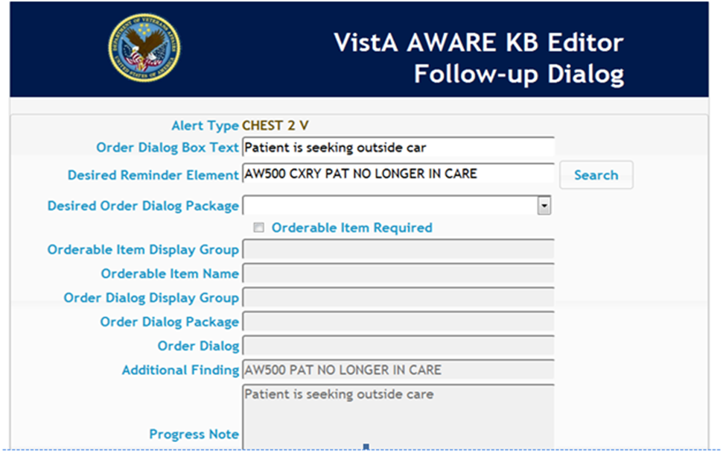

Figure - Follow-up action Form of Follow-up Dialog Group

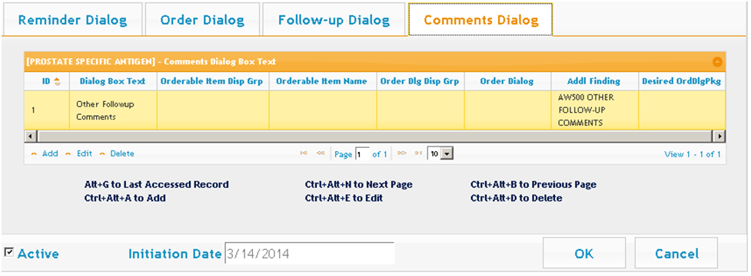

Figure - List of Follow-up actions in Comment Dialog Group

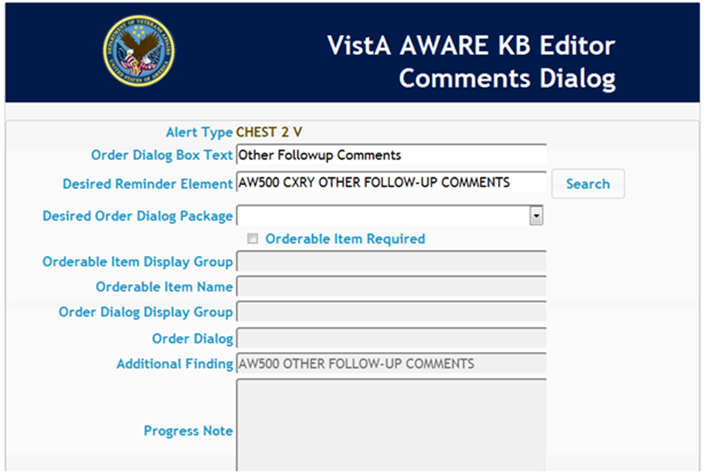

Figure - Follow-up action Form of Comments Dialog Group

## QI Tool

The QI Tool functionality is comprised of a web Alert Cache Viewer to view Alert Cache file stored in Vista Server, and a much more comprehensive web QI Reporting Tool to view historical critical Alerts stored in SQL Server. The Alert Cache Viewer is an application designed for providers and patient safety officers to view current critical alerts, the AWARE alert data. The Web QI Reporting tool on provides users with longer-term (historical) critical alert data with a statistical perspective.

### Alert Cache Viewer

Alert Cache Viewer displays the contents of VistA’s VEFA AWARE Alert Cache file whose data collected determines how well follow-up actions have been made with associated unacknowledged recent and current alerts tracked under AWARE.

Entries in the Alert Cache file are populated by a TaskMan process, which tracks critical alerts as defined in the AWARE Alerts Category and Alert Type files. Alert Cache file size (cache) is configurable, but is intended for 30 days for the most recent critical alerts. It allows opportunity with regular Vista access to see all recent patient alerts of a provider or other same team provider or surrogated provider. Similarly, it allows opportunity for a patient safety officer with regular Vista access to see all patient alerts for all providers across a facility.

Thus it allows opportunity on a more instantaneous basis to pro-actively make decisions to address these alerts (via CPRS by these ordering providers or on behalf of these ordering providers by other providers) that still require follow-up action(s) so as to help make timely follow-ups within a current 7 day window to deliver proper patient care with a patient safety net across all patients. through below show Alert Cache Viewer User Interfaces.

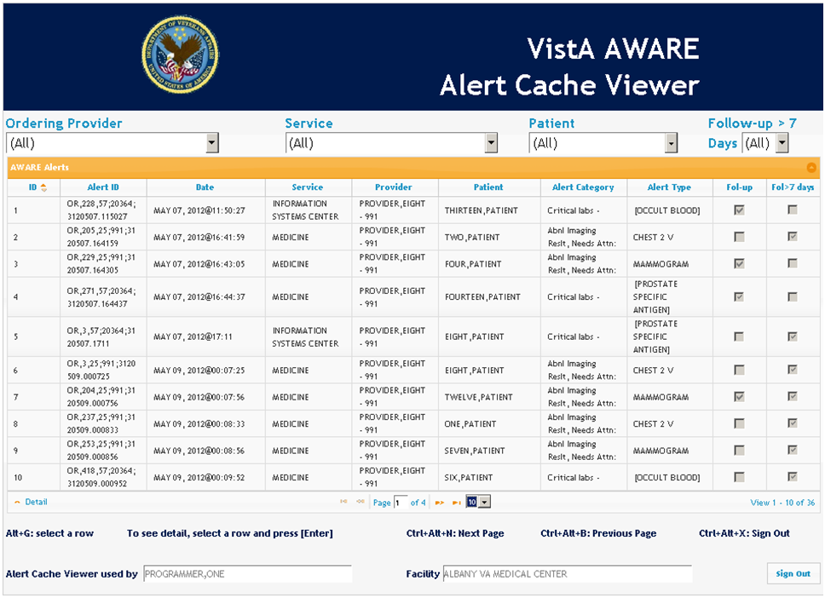

Figure - List of Cached Critical Alerts

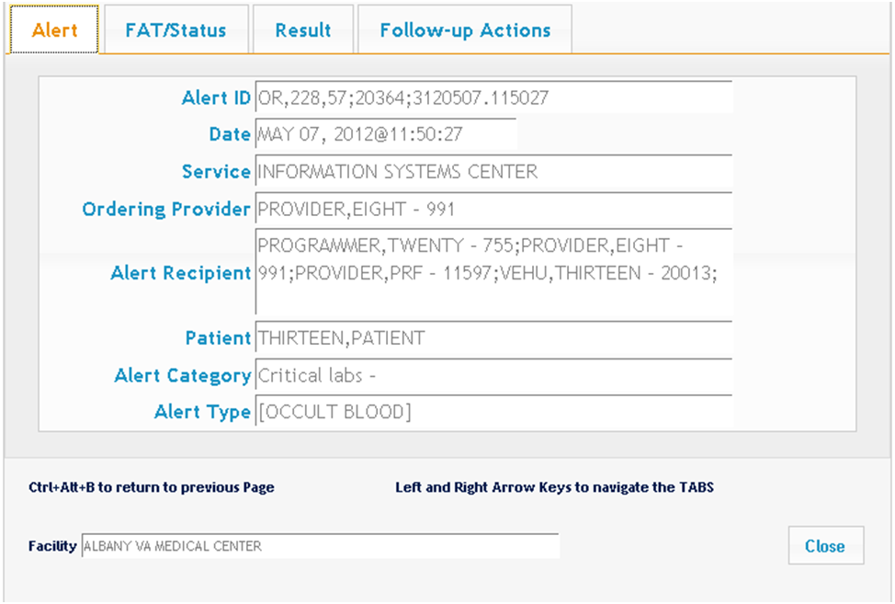

Figure - Detail: Cached Critical Alert Information (GENERAL)

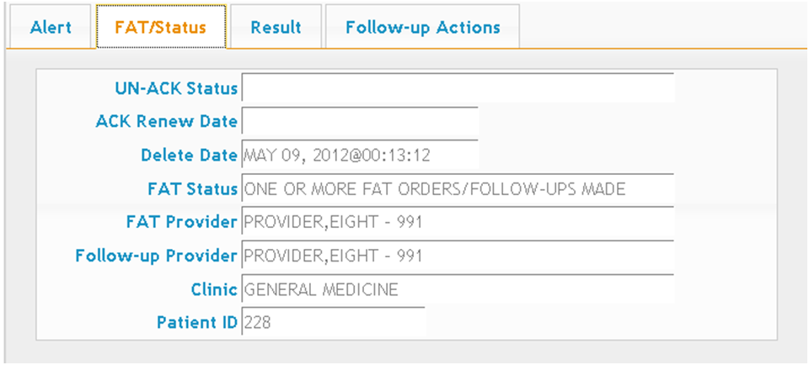

Figure - Detail: Cached Critical Alert (FAT/STATUS)

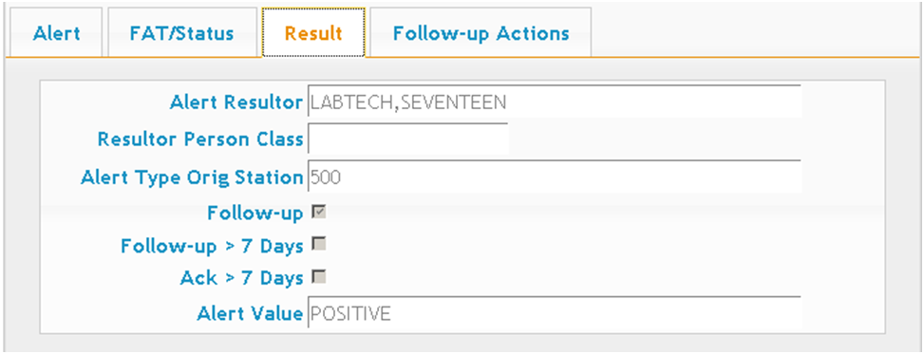

Figure - Detail: Cached Critical Alert (RESULT)

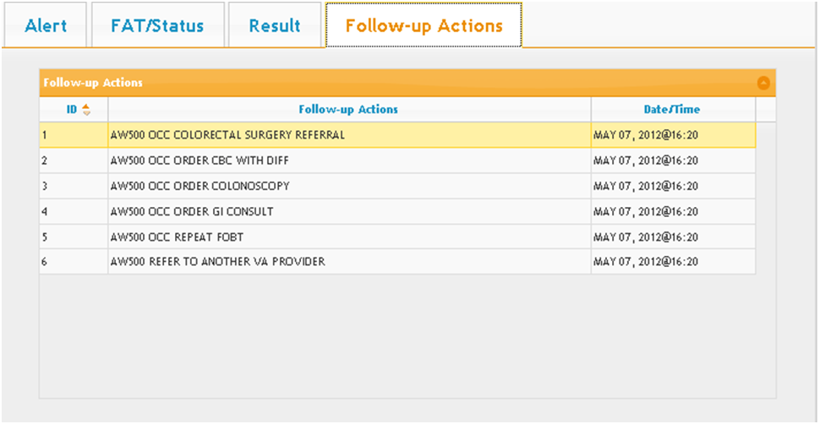

Figure - Detail: Cached Critical Alert (FOLLOW-UP ACTIONS)

### QI Reporting Tool

The QI Tool is a web reporting user interface to determine how well follow-up actions have been made with associated unacknowledged alerts tracked under AWARE. From data gathered from VistA sites, and transferred into site Alert tracking files and subsequent MS SQL Server database tables, it will report across services, clinics, providers, etc. at both a summary and detailed level for tracked alerts with and without follow-up action(s) completed. It is intended to be implemented using MS SQL Server Reporting Services and auxiliary web reporting tools. Authorized users, primarily clinician providers whose own alerts are being tracked, can view their own activities updated daily with various provider detailed and summary reports over a recent period of time to do pro-active actions on their own alerts within a 7 day window of opportunity, and can view the activities for longer (historical) periods of time where after that period it will be considered late on delivering proper service. Administrative staffs are the other users of these reporting/tools. Patient safety officers will be able to look at various detailed and summary reports of their own site’s recent data across their own sites (VA services, clinic, provider, etc.). For reporting of longer-term SQL server tracked alert data, other administrative staff, such as health system specialists and other director level personnel, or chief of staff level personnel, can see trend levels in performance with all these reports through MS SQL Server reporting services.

The QI Tool is an ASP.NET Web Application that is tightly integrated with MS SQL Server and MS Reporting Services. This provides a complete platform for the delivery of alert reports from the AWARE database. The QI Tool is capable of authenticating and authorizing users in the viewing of the reports packaged with the AWARE solution as well as any custom reports that may come post installation, provided they are installed to the AWARE reports folder.

#### Logon screen

When the user first launches the QI Report Manager Tool, the system will check to see if a current session is available for the user to browse. If there is no session available for the current http user context, then the system will redirect the user to the Login screen where the user may enter their credentials to access the system. The screen is shown in .

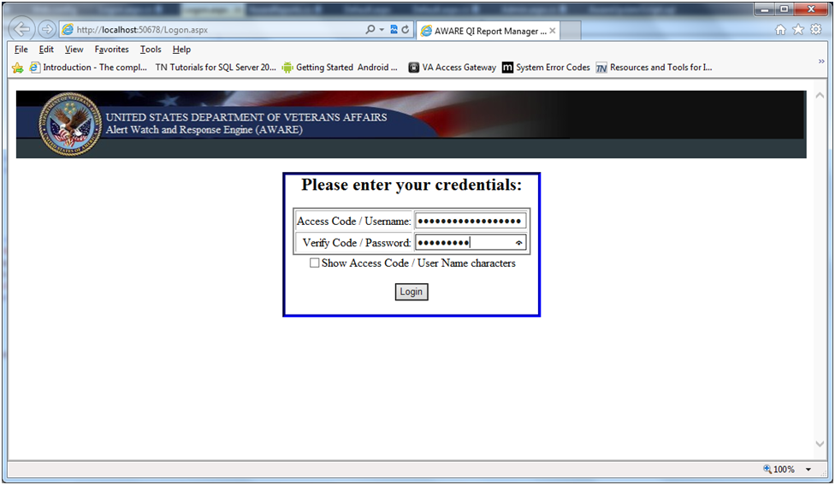

Figure - QI Report Manager Logon screen 1

On this screen, the user will enter their credentials for accessing the system.

**Access Code/Username:** The access code/username name by default can either be masked as shown in or unmasked as shown in . The setting for controlling the masking by default is defined in the web.config file by the name of “LogonUserNameIsMasked”. When this setting is set to true, the access code/user name will be masked and the “Show Access Code/User Name characters” check box will be unchecked.

The access code/user name text box can also be set to default to the current user who has logged into Windows. When this setting is enabled, the access code/user name text box becomes non-editable, and the setting is stored in the web.config file by the name of “SharedComputer”. This setting is set to true by default to allow multiple users and multiple type users to access the system from a single computer without logging in and out of the system.

**Verify Code/Password:** The verify code/password text box will always mask the users input as to keep it private.

**Show Access Code/User Name characters:** The show access code/user name checkbox allows a user to verify the input of their access code or user name. When the checkbox is checked, the user will be able to see the input in readable characters as shown in , when the checkbox is not checked the input will be masked as shown in .

**Login:** When the user clicks the login button, the system will verify the provided credentials against 1 of 3 different types of logons.

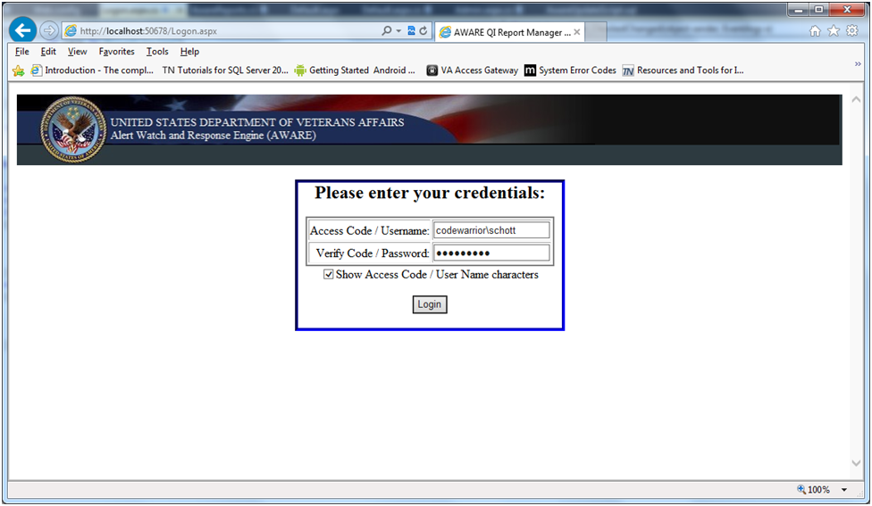

Figure - QI Report Manager Logon screen 2

After the user has clicked the login button, the provided credentials will be validated in the following waterfall fashion.

**Active Directory:** The active directory is queried for the existence of the account provided in the Access Code/User Name text box. If the account is found, the credentials are then passed to the credential store to determine if the credentials are valid. Active directory logon is only valid for super users at the time of this writing. If there are some common active directory groups among the users then that role can be expanded. Upon initial installation of the application, there are no users or groups set up in the system; because of this, the system needs a way to validate the user for initial setup. In the web.config fie there is a setting by the name of “SuperUsers”, in this list there needs to be at least one name to access the system for configuration. Although this list can host multiple names it is recommended only for those who will be responsible to maintain the system. If a valid active directory account is used in the logon process and that account does not exists in the super users list, then access will not be granted.

**Local Application User:** If the active directory verification failed, then the credentials are processed against the local application users. These are users that a super user would set up to have designated rights for the specific users. A local application user can also be a member of the super users list. These credentials are stored in the USERS table of the AWARE database.

**Vista Access Verify codes:** If the local application user verification failed, the final check would be to validate the supplied credentials to VistA via a web service. If this verification succeeds, then the user will gain access to the QI Tool based upon the group retrieved from VistA. If this verification fails, then the user is returned to the logon screen with an error message identifying why the verification failed.

After successful verification of the supplied credentials the user will be directed to the QI Tool main screen as shown in .

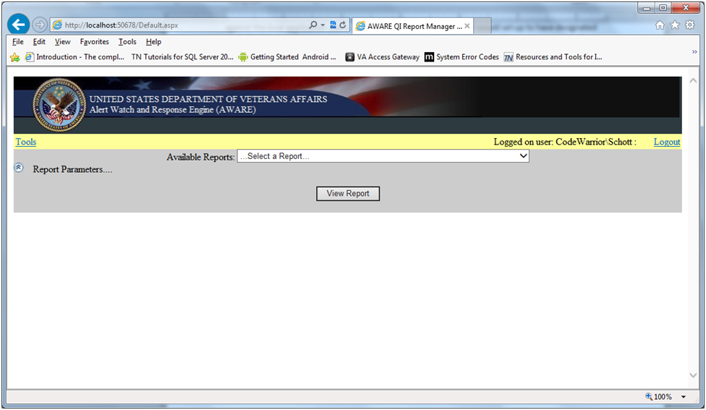

Figure - Validated as Super User

In the logged on user was validated as a super user. When a user is designated as a super user they are able to move around in the application unchecked; they have access to everything the application can do. When the application is run under the super user context there will be a “Tools” link in the yellow banner bar. The super user would click the Tools link to configure the QI Tool application.

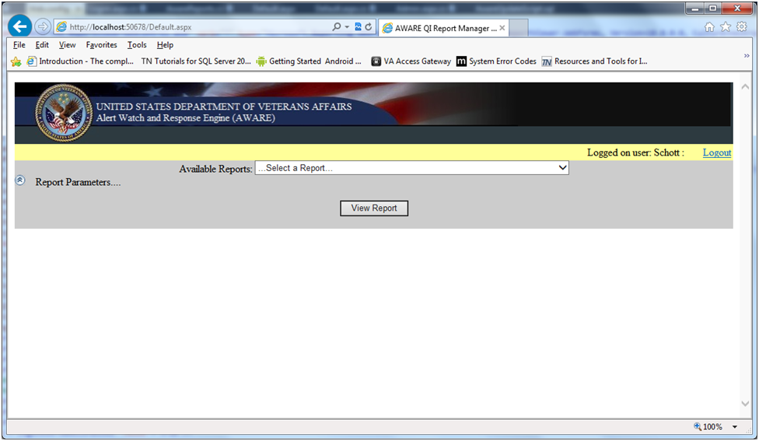

Figure - Validated as Local Application User

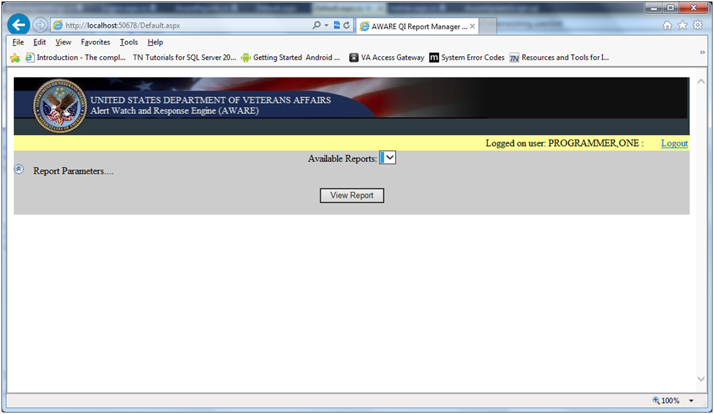

Figure - Validated as VistA User

and show the screen as authenticated as a local application user and VistA user. All users will receive Logged on user identifier and logout link on the right side of the yellow banner bar.

**Logout:** When the super user clicks the “Logout” link, their session will be closed and will return the user to the logon screen.

**Available Reports:** Just below the yellow banner bar is drop down list of available reports based on the credentials entered during the logon process. A super user will see all reports on the reporting services server. During the initialization of the application, the QI Tool will query the Reporting Service for all reports located in the defined root folder. In the web.config application there is a setting by the name of “ReportsRootFolder” that defines where the root folder is.

**Report Parameters:** The report parameters are a dynamic panel of parameters to pass to the reporting service engine for report generation. It is updated every time a different report is selected from the available reports drop down list. shows the dynamic report parameters panel.

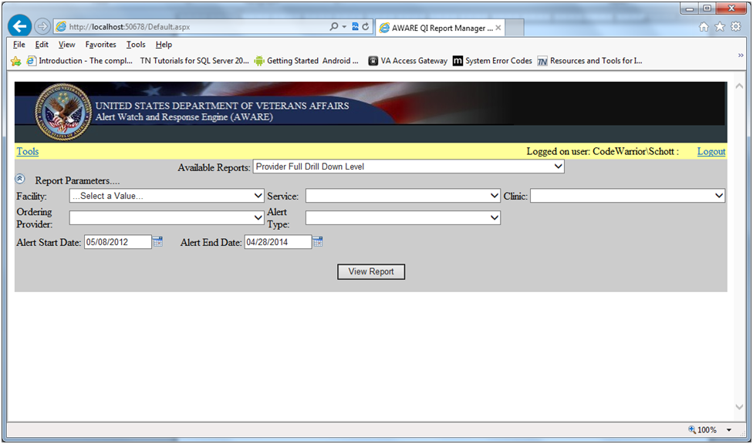

Figure - Dynamic Reports Parameter panel

Each parameter for any given report starts at the facility level and progressively narrows the criteria for each report. shows a report with the maximum number of available parameters. Other types of report might have fewer parameters.

**Start and End Dates:** All reports will have Alert Start and End Date parameters; the default for the Alert Start Date can be set by a setting in the web.config file by the name of “DefaultStartDateSpan”. This Alert Start Date shown in is set at 720 days. The default is 90.

**View Report:** When the user clicks the “View report” button, the application will gather the parameters and pass them to the reporting services web service to generate the selected report in the Available Reports drop down list as shown in .

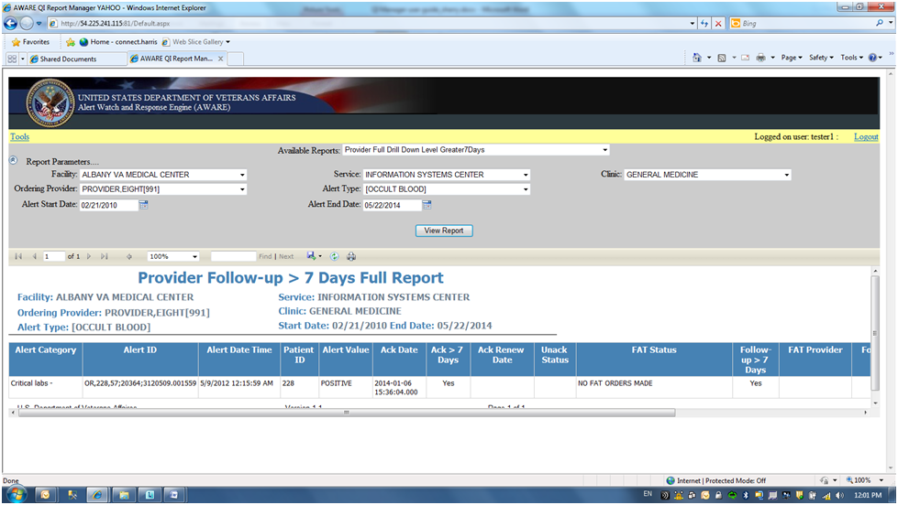

Figure - Selected Reports Generated.

When the report is generated by the reporting service, an additional toolbar will be present which facilitates the user to navigate the pages of the report, to zoom in the visibility of the report, search for text within the report, options for exporting the report, refreshing the report based on the selected parameters the report was initially executed with, and the ability to print the document.

The reporting service web service is configurable in the web.config file through a setting by the name of “AwareQIManager_Reportingservice2010_ReportingService2010“. Through this setting you can set the http/https identity and port. It is important that this matches the installation endpoint. It can be discovered through the Reporting services Configuration Manager installed when MS SQL Server was installed.

#### QI Tool - Tools

When the super user clicks the Tools link in the yellow status bar the user will be presented with the QI Tool Administration Tools screen as shown in .

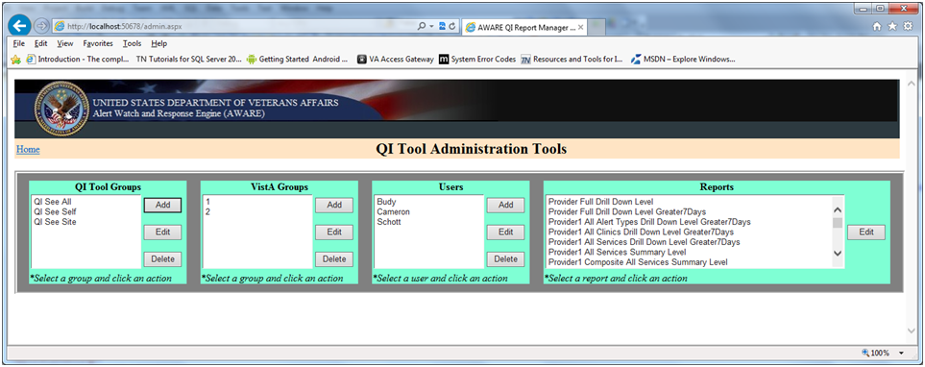

Figure - QI Tool Administration Tools

On the QI Tool administration Tools the super user is able to create QI Tool based groups, define expected VistA Groups, create QI Tool based users, and modify the presentation name for the discovered reports.

**QI Tool Groups:** At the time of this writing, the security authorization for the QI Tool begins at the QI Tool Groups. It is here that the super user may define a group, authorize which reports the group is authorized to view and assign local application users (Users) to the groups. There is no limit on the number of groups that can be defined. The super user may add, edit, or delete QI Tool Groups from this screen.

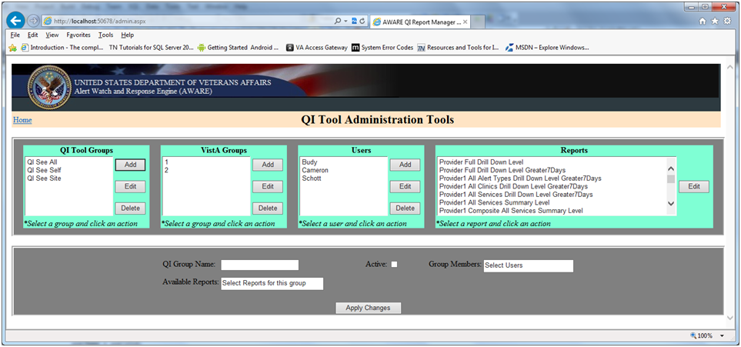

Figure - QI Group Panel – Add Mode

In the QI Group panel shown in the super user may define the name and mark the group as being active or inactive. The Available Reports drop down list displays all the reports that were discovered when the application was initialized. The Available Reports list has checkboxes for the super user to select, and as shown in , multiple report selections are permitted. The Group Members drop down list contains all application-defined users where specific authorizations are needed. The Group Members list has checkboxes for the super user to select as shown in . Multiple user selections are permitted.

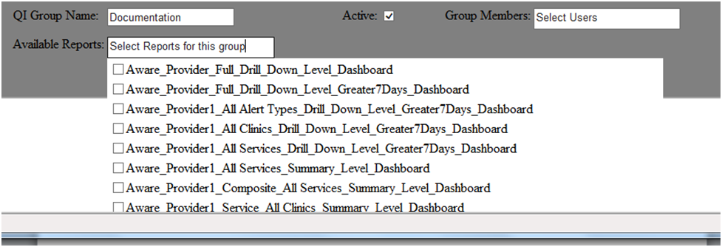

Figure - Available Reports Drop-Down List

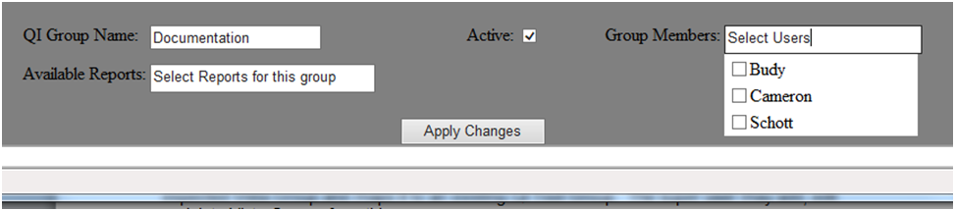

Figure - Group Members Drop-Down List

If the super user chose to “edit” a selected QI Group, the name would be populated, the active checkbox would be marked to its current status, and the available reports and group members would be selected.

When the super user clicks the ‘Apply” button, the new group would be added to the database if the user was in the “Add” mode. If the user was in the “Edit” mode, the changes for the selected group would be updated to the database. All fields in the QI Group panel would be re-initialized.

If the super user chooses to “Delete” a selected group a warning prompt as shown in .

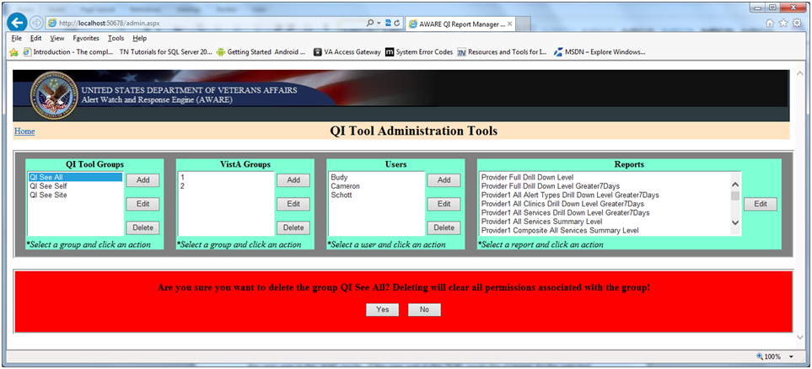

Figure - Delete QI Group Warning

**Yes:** When the super user clicks the “Yes” button, the selected QI Group would be deleted from the database along with the associated group authorizations. The users of these groups would remain with no authorizations.

**No:** When the super user clicks the “No” button, the delete action is cancelled and nothing is done affecting the selected QI Group.

**VistA Groups:** When a user logs in using their Access/Verify key pair, those credentials are passed to the VistA web service for verification. If the verification is successful the web service will return the VistA user group for this user. It is here where the super user defines the expected Vista Group and maps it to an existing QI Tool Group as shown in . The super user may add, edit, or delete Vista Groups from this screen.

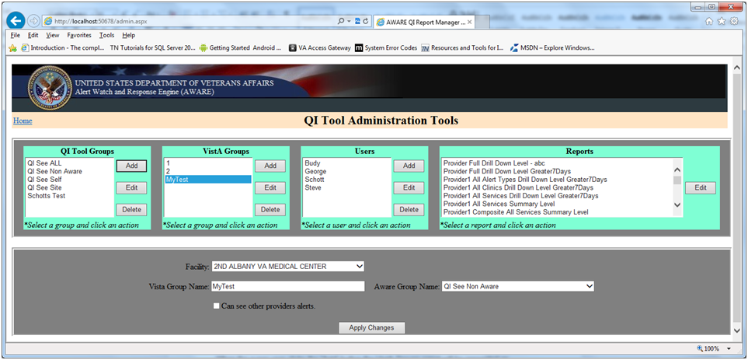

Figure - VistA Groups Panel – Add Mode

When the super user clicks the “Add” button, the VistA Groups panel will be presented as shown in .

The Facility drop down list will list all the facilities, which are available for this installation and stored in the database in the FACILITIES table. This field is read only.

The Vista Group Name is the name from VistA for the intended group. It must be exactly the same name as passed from the VistA web service. This field is used as a mapping; readability is only of concern to the application.

The Aware Group Name is a drop down list with all the available QI Tool Groups, which are active as shown in . This drop down list allows a single selection only.

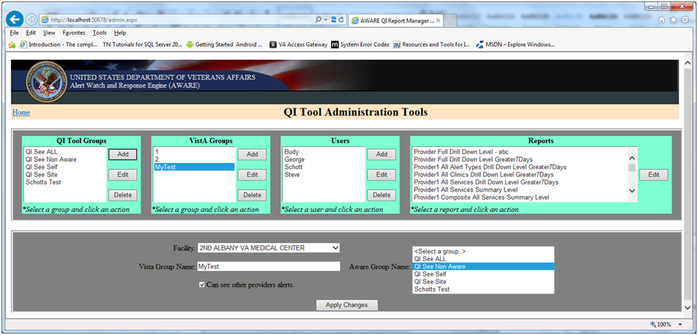

Figure - VistA Groups – Aware Group Drop Down List

The “Can see other provider’s alerts” checkbox identifies whether this specific Vista Group can see other providers alerts or just their own. If the checkbox is checked, then any provider belonging to this group will be able to see all the providers’ alerts. If the checkbox is not checked, then the provider will only be able to see their own alerts.

If the user chooses the “Edit” button, the details for the selected VistA group would be pre-populated

When the super user clicks the “Apply” button, if in the “Add” mode, the new group mapping will be written to the database. If in the ‘Edit” mode, the changes will be updated to the database. These mappings are stored in the database in the AWARE_VISTA_GROUP_MAPPINGS table.

If the super user clicks the “Delete” button, they will be presented with a warning prompt as shown in .

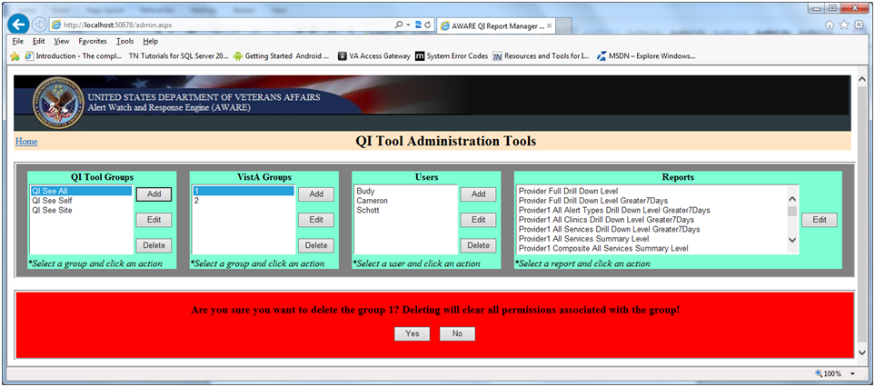

Figure - VistA Group Deletion warning

**Yes:** When the super user clicks the “Yes” button, the selected VistA Group will be deleted from the database along with the associated group mapping. The providers who belong to this VistA group will be denied access, as there would be no mapping to authorizations.

**No:** When the super user clicks the “No” button, the delete action is cancelled and nothing is done affecting the selected VistA Group.

**Users:** The super user can define local application users for any situation where a user may not have a valid access/verify key pair without making that user a super user. These users are stored in the database in the USERS table. The super user may add, edit, or delete users from this screen. When the Add or Edit button is clicked, the Users panel will be presented as shown in .

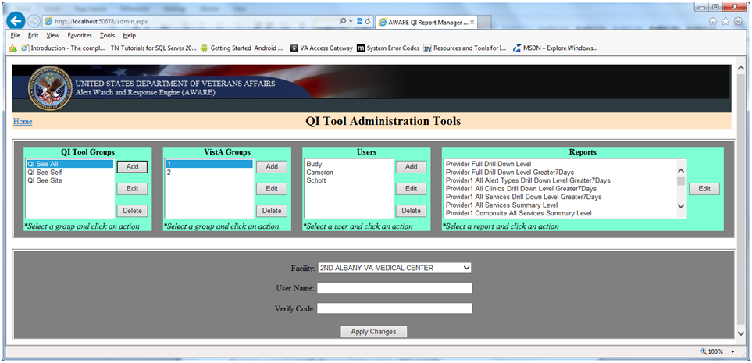

Figure - Users Panel – Add Mode

The Facility drop down list will show all the facilities that are available for this installation and be stored in the database in the FACILITIES table. This field is read only.

The User Name field is where the name is input for the specific user.

The Verify Code is where the users verify code /password would be entered. This field is encrypted in the AWARE database stored in the USERS table; the characters are not masked on the UI to facilitate easy retrieval and accuracy when entering.

When the super user clicks the “Apply Changes”, if in “Add” mode, the new user will be added to the database. If in “Edit” mode, the selected users’ details will be updated to the database.

If the super user clicks the ‘Delete” button after selecting a user, a warning will prompt the user for confirmation, as shown in .

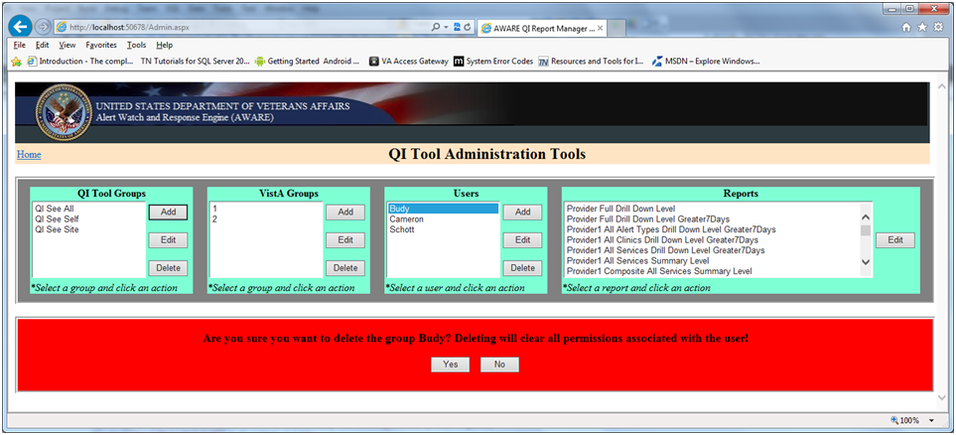

Figure - Delete User Warning Prompt

**Yes:** When the super user clicks the “Yes” button, the selected User will be deleted from the database, along with any authorizations associated with the selected user.

**No:** When the super user clicks the “No” button, the delete action is cancelled and nothing is done affecting the selected User.

**Reports:** To facilitate easier reading and allow the super user to identify the discovered reports, the super user can modify the presentation name of the reports. When the user selects a report from the report listing and clicks the “Edit” button, the Reports panel will be displayed as shown in .

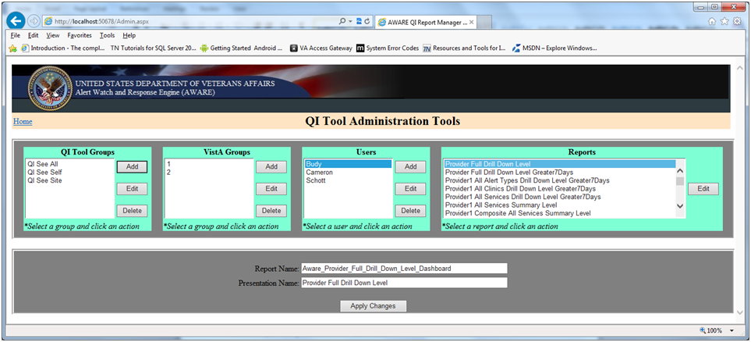

Figure - Reports Panel

**Report Name:** The report name is the actual name of the report as known to the application and reporting services.

**Presentation Name:** The name that appears in the application for the user to see. This name can be anything that makes it easier to use, with the only constraint being it has to be unique.

When the super user clicks the “Apply Changes” the new presentation name is updated to the AWARE database in the SECURITY_ITEMS table.

**Home:** The “Home” link in the left hand side of the tool bar allows the user to navigate back to the home page of the application.

# Attachment A - Approval Signatures

The following members of the governing IPT are required to sign. Please annotate signature blocks accordingly.

__________________________________________________________  
Signed: Date:  
Blake Henderson   
Project Manager  
Innovation Coordinator

__________________________________________________________  
Signed: Date:  
Brian Stevenson   
Contracting Officer’s Representative  
Innovation Coordinator  
VHA OIA Innovation